Digital Connectivity and Mental Health Among Women in Bangladesh: A Rural-Urban Perspective
Md. Salek Miah¹ and Md Jamal Uddin¹*
Department of Statistics, Shahjalal University of Science and Technology, Sylhet-3114, Bangladesh

Corresponding Author
Md Jamal Uddin
Email: jamal-sta@sust.edu

Abstract
Background:
Expansion of digital connectivity is taking place at a tremendous pace across low- and middle-income countries (LMICs), whereas the psychological effects of internet use and ICT exposure among women are not adequately studied. This study examines the association between internet use, ICT use, and ICT ownership, with depression and anxiety symptoms among ever-married women in Bangladesh, stratified by rural and urban settings.
Methods:
The study used nationally representative data for 18,987 ever-married women aged 15–49 years from the 2022 Bangladesh Demographic and Health Survey. Symptoms of depression were assessed with the PHQ-9 instrument, and symptoms of anxiety were assessed with the GAD-7 instrument. Multivariable logistic regression analyses for complex survey design and stratified by residence (urban/rural) were used. Results were presented as adjusted odds ratios (AORs) with 95% confidence intervals (CIs). Spatial distributions of internet, ICT access, and mental health outcomes were also examined.
Results:
Among rural women, more ICT use was significantly associated with higher odds of depression (AOR: 1.38; 95% CI: 1.12–1.69), whereas internet use and ICT ownership were not significantly associated. In the urban areas, high ICT ownership was significantly associated with depression (AOR: 1.81; 95% CI: 1.01–3.25) and anxiety (AOR: 2.11; 95% CI: 1.14–3.92). Internet use and ICT exposures were not significantly associated in urban settings. Spatial analysis revealed geographic clustering of mental illness symptoms with uneven distribution in divisions that possessed low digital access alongside poor socioeconomic markers such as Rangpur and Rajshahi.
Conclusions:
Bangladesh's digital revolution must be accompanied by context-sensitive mental health policy. Policy makers must address rural–urban disparity, invest in mental health literacy, and integrate psychosocial support into digital infrastructure development.

Keywords: Mental Health, ICT, LMICs, Stratified Analysis, Spatial Analysis, Married Women
Introduction
Mental illness, particularly anxiety and depression, is a leading cause of worldwide disability, affecting over 970 million people across the world(1). Mental disorders contribute significantly to the global burden of disease and are linked with substantial social, economic, and health consequences(2). Information and Communication Technology (ICT) ownership refers to access to transmission-related tools within a household, such as televisions, radios, mobile phones, and smartphones(3). It represents basic access to modern or conventional media and serves as a proxy for a household’s access to information and services. ICT usage refers to the actual involvement of individuals with media content delivered through these technologies(4). It is typically assessed by self-reported frequency of media exposure, such as reading newspapers, listening to the radio, or watching television(5). It reflects media consumption behavior and the magnitude of informational reach in an individual’s daily life(6,7). Despite widespread concern about mental illness, there remains an enormous treatment gap, especially in low- and middle-income countries (LMICs), where there are minimal resources and little awareness(8,9). The pandemic of COVID-19 has further escalated the prevalence and impact of mental health disorders, thereby highlighting the importance of identifying contributory factors and enforcing effective interventions(10,11).
The mental health disorder burden is not evenly spread. Africa and Asia have a disproportionate share of this, compounded by socioeconomic circumstances, cultural taboos, and poor healthcare infrastructures(12). In South Asia, Bangladesh is witnessing explosive demographic and technological transitions altering social situations, but mental health care is poorly funded and deprioritized(13). Bangladesh, a lower-middle-income country with more than 165 million people, bears an underestimated and significant burden of mental disorders among women, particularly among ever-married women who are likely to experience gender-related stressors, including reproductive health issues, intimate partner violence, and limited autonomy(14,15). The available evidence from Asia and Africa indicates heterogeneous depression and anxiety prevalence among women, with risk factors including age, education, parity, reproductive coercion, and empowerment status(16–19). The extent to which exposure to digital technologies contributes to or modifies mental health outcomes in such settings remains unclear(20). Several studies have not made a distinction between ICT ownership and ICT usage, or between controlling for urban-rural variation(21). Additionally, few large nationally representative studies have employed rigorous survey-weighted analysis to analyze these correlations in South Asian female groups, particularly in ever-married women who are subject to certain sociocultural pressures(22). In Bangladesh, recent cross-sectional studies show moderate to high rates of anxiety and depression among women, influenced by sociodemographic, reproductive, and empowerment factors(21). But little is known about how digital inclusion in the form of internet access, ICT ownership, and use is associated with mental health(23).
The primary causes of poor mental health status among women of reproductive age include pregnancy loss, intimate partner violence, limited decision-making power among women, poor nutrition, and socioeconomic status(18,19). However, several studies suggest that some media access factors particularly household internet status, ICT ownership and usage also play a vital role in mental health(24). Excessive internet usage has been associated with increased risk of mental health disorders, lifestyle disruptions, and reduced well-being. One study found that optimal levels of internet use and ICT ownership were significantly associated with better mental health outcomes(25,26). Another study in Bangladesh showed an association between ICT ownership, and usage was significantly associated with lower anxiety, and depression among women(27,28). Women who live in rural settings face information inequality and mental health information gaps compared to urban women in Bangladesh. Rural women are significantly less likely to access print or broadcast media regularly, limiting their empowerment and access to health information(29). All these studies have shown us that there is a significant association between mental health status and internet usage, ICT ownership, and usage. But the mechanism of association between mental health status with internet usages, ICT ownership, and its usages is not clear, therefore this study aims to examine this association systematically(30–33). Although several studies have explored individual determinants of mental health status among ever married women, limited research has systematically examined the association between mental health status and internet usages, ICT ownership, and ICT usage using geospatial, and rural-urban stratified analysis in the Bangladeshi context(34–38).
Objectives
1)This study aims to assess the association of the mental health outcomes with internet use for the entire population under study. 2) Examine the correlation of mental health with the ICT usage behaviors, ownership of ICTs, or both. 3) Analyze how the prevalence of the mental health outcomes spatially differs across administrative divisions in association to three key ICT exposures. 4) Perform analyses separated by urban and rural residence to assess whether the relationship between the three ICT-related exposures and mental health differs by geography.
Methodology
2.1. Data source
This study is based on the cross-sectional secondary data set of the most recent 2022 BDHS survey, which was the 9th round nationwide cross-sectional survey (Bangladesh Demographic and Health Survey 2022 Final Report, 2024). This survey was conducted by the National Institute of Population Research and Training (NIPORT) in collaboration with the Health Education and Family Welfare Division of the Ministry of Health and Family Welfare, Government of the People’s Republic of Bangladesh. The survey was implemented by Mitra and Associates, and ICF International provided technical assistance. The survey was conducted in four phases, each lasting approximately 4 weeks, from June to December 2022.
2.2. Sampling design and sample size
The BDHS 2022 nationally representative survey followed a two-stage stratified random sampling technique. A complete list of enumeration areas (EAs) covering the whole country was prepared by the BBS for the 2011 population census of the People’s Republic of Bangladesh and used as a sampling frame. The primary sampling unit (PSU) for the survey is an EA, which contains approximately 120 households on average. A total of 30,358 ever-married women age 15–49 was identified as eligible for individual interviews, among them, 30,078 women were finally interviewed, with a response rate of 99%. The BDHS-2022 report discusses, in detail, about sampling process, data collection procedure, quality control, and survey questionnaire (Household questionnaire, Individual questionnaire, etc.) (Bangladesh Demographic and Health Survey 2022 Final Report, 2024).

30,078 eligible women were interviewed with a response rate of 99.1%

Among them, data were collected form 28,537 women of reproductive age (15-49) year

1,541 women were excluded due insufficient data

Internet User, ICT ownership & ICT usage 18,987

Last 12 months use 5,486
Data for 13501 women were excluded
In the first stage, a total of 674 enumeration areas (EA) were selected using PPS
In the second stage, a total of 30,330 residential households were selected, with 45 households chosen equally from each of the EA

A total 30,358 women were found eligible for the interview in 30,018 households

280 eligible women refused to participate in the interview

Not Used (Not at all, less than one week) N=1,234
Used (At least one week) N=4,252

312 households refused to
participate in the interview or was out of reach

Data for 9950 women were
excluded due to insufficient data

Figure 1: Study design of Bangladesh Demographic Health Survey, 2022
Outcome variables
The study considered two primary mental illness outcomes, and they were depression and anxiety. Depression was assessed using Patient Health Questionnaire-9 (PHQ-9), and any score equal to or greater than 10 was adopted to indicate severe depressive symptoms. The variable was also dichotomized to identify 1 as PHQ-9 scores ≥10 and 0 for scores <10. Anxiety was also assessed using the Generalized Anxiety Disorder-7 (GAD-7) questionnaire, and a score of 10 or more was used to denote clinically relevant anxiety. Anxiety was operationalized as a dichotomous variable (1 for GAD-7 ≥10, otherwise 0), just like depression(39).
Exposures
Three large exposure variables were constructed to measure different dimensions of digital access and media consumption. Internet use was measured using the self-reported frequency variable and re-coded into a binary measure. Respondents who reported never or rarely using (codes 0–2) the internet were labelled as non-users (0), while respondents with high frequency of use (codes 3–4) were labelled as users (1). Second, ICT ownership was operationalized as a composite of four device ownership indicators: television, radio, mobile phone, and smartphone. Each device was assigned the value 1 if owned and 0 otherwise. A range score of 0 to 4 was developed to indicate total ICT ownership. The same was dichotomized into two categories: no ownership (0) and any ownership (1, for one or more devices). Third, ICT usage captured frequent exposure to traditional media sources. Respondents' frequency of use of newspapers, radios, and television sets were each recoded into binary indicators, with frequent use (code 2) being recoded to 1 and infrequent or no use (codes 0–1) recoded to 0. The three indicators were added up to create a total ICT usage score ranging from 0 to 3, and dichotomized as: no frequent use of any medium (0) and frequent use of one or more mediums (1). These variables were designed to capture both ownership (access) and usage (use) dimensions of information and communication technologies for mental health outcomes.
Covariates
A number of covariates at the individual level were included to adjust for any potential confounding between internet use and mental health outcomes. Sociodemographic characteristics covered were age, education, religion, residence, geographic division, household wealth, household size, sex of the household head, current work status, and father's education. Age was classified into seven classes: 15–19, 20–24, 25–29, 30–34, 35–39, 40–44, and 45–49 years. Women's education was classified as no or primary education, secondary incomplete, and secondary or higher. Religion was classified as Muslim or non-Muslim. Residence was classified as urban or rural, and region was indicated by administrative division. The wealth index of the household was re-coded into three categories: poor (poorer and poorest), middle, and rich (richest and richer). Household size was categorized into small (1–3 members) and large (4 members and more). Sex of the head of the household and current working status of the respondent were also controlled. Education level of the father was controlled as a categorical variable. Reproductive characteristics were: number of surviving children, currently pregnant, recent menstruation, not having had sex, marital history, and living with husband or spouse. Surviving children numbered none, 1–2, or 3 or more. Women were classified as currently pregnant if they replied yes to being pregnant at the time of the survey. Menstruation in the past six weeks and self-reported never having had sexual intercourse in the current period were both recorded as binary variables. The marital unions were categorized as once or more than once, and current co-residence with husband/partner was recorded as a binary variable too. Husband's desire for fertility was recorded as desired as many or more children as the woman had fewer, and women were also asked if they ever felt pressured to get pregnant. Empowerment was assessed using five decision-making indicators: health care, size purchases in the household, visits from family or relatives, money control, and family planning. The women were ranked as empowered if they had autonomy over decisions in three or more of the five domains. Decision-making autonomy over contraceptive use was also coded respondent/joint decision vs. husband/other. Gender attitudes were captured by five justifications of intimate partner violence (IPV) questions. A dummy variable was created to indicate whether the respondent justified IPV for at least one condition(40).
Statistical Analysis
This study conducts univariate and bivariate analyses to assess the association between Mental health with internet status, ICT ownership, and ICT usages with 5% level of significance. Covariates with noteworthy associations (p < 0.025), with those that were deemed theoretically significant, were retained for multivariable analysis. Crude and adjusted odds ratios (ORs) for each outcome were modeled using multivariable logistic regression models. Variance inflation factor (VIF) was used to test multicollinearity, and an acceptable level was considered as <5. Model fit was evaluated using both the Pearson chi-square test and the Hosmer–Lemeshow test based on deciles of predicted probabilities. To examine potential effect modification, stratified analyses by residence area (urban vs. rural) were conducted. For spatial analysis the depression and anxiety prevalence were calculated as division wise percentage by using STATA 17 exported to MS Excel format and finally, import R studio 4.4.1, and using sf,sp, ggplot2, and tmap packages for visualizations. Observations with missing data on any of the major outcome or exposure variables were excluded from the analysis. For complex survey design, sampling weights, with clustering adjustment (primary sampling unit v021) and stratification adjustment (v022) carried out with the svyset command.
Ethical Considerations
The final models were estimated with careful regard for model assumptions, confounding, and interaction effects. Ethical aspects, such as approval from the Demographic and Health Surveys (DHS) program and informed consent of participants, are discussed in the full manuscript. The study obtained permission for the use and access of the BDHS 2022 dataset from the Demographic and Health Surveys (DHS) Program after complying with their standard data request process. No additional ethical approval was required since the study is based on publicly available, anonymized secondary data. The BDHS 2022 survey protocols were reviewed and approved by the Institutional Review Board (IRB) of ICF International, USA, and the Bangladesh Medical Research Council (BMRC). Written informed consent was given by all participants at the time of initial data collection. For respondent's younger than 18 years of age, consent was obtained from the guardian or parent, along with assent from the minor participant. All the data were de-identified to ensure confidentiality and privacy in accordance with DHS data protection guidelines.
Results
Of the 18,987 women, 914 (4.8%) were depressed, and 18,073 (95.2%) were below the cut-off. For anxiety, 779 (4.1%) of the participants scored 10 or higher on the GAD-7, while 18,208 (95.9%) were below the cut-off level [Figure 1].
Depression and anxiety prevalence were determined using internet exposure levels of internet use, ICT use, and ICT ownership. Out of the individuals that were screened as having anxiety, 77.8% were internet users, whereas 22.2% were not. Similarly, 80.8% of the individuals who were depressed were internet users, whereas 19.2% were not. In the case of ICT usage, fear was prevalent in 53.5% of the non-users and 46.5% of the users. Depression was prevalent to an equal extent among both groups (50.0%). Concerning ownership of ICT items, 83.5% of the anxious people and 81.9% of the depressed respondents reported owning the items, while 16.5% and 18.1% respectively, were the non-owners [Figure 2]. The prevalence of anxiety and depression was much higher in the rural population compared to the urban population. Out of all subjects who were screen positive for anxiety, 66.9% were rural and 33.1% were urban. Similarly, out of all subjects who were screen positive for depression, 67.4% were rural and 32.6% urban [Figure 3]. The prevalence of anxiety and depression prevalence were 4.1% and 4.7%, respectively. Internet use and ICT ownership were not significantly associated with either outcome, but ICT use was associated with higher anxiety (p = 0.045). Both disorders were higher with parity and increasing age, and highest among less educated women (p < 0.001). Justification of intimate partner violence and reproductive vulnerability were significantly associated with adverse outcomes. Women with less decision-making autonomy were more likely to report lower anxiety (p < 0.001). Highest prevalence in Sylhet and Rangpur, and lowest in Rajshahi and Mymensingh (p < 0.001). Poor women had more depression, and higher paternal education was always protective (p < 0.001). [Table 1] There were no associations with internet use, ICT ownership, or ICT use. There was a consistent age gradient with increased odds for both conditions in older women. Higher maternal and paternal education was strongly protective (p < 0.001). Reproductive risk particularly recent pregnancy forcing and high parity as well as a lack of menses was significantly associated with increased odds of poor mental health. Women in most unions and those justifying IPV were also at increased risk. Regionally, women from Rangpur and women who identified as Muslim had increased odds for both, with wealth being weakly inversely associated with depression. There were no significant relationships with types of households or employment status [Table 2]. Unadjusted models showed no statistically significant associations between digital exposures and depression or anxiety, as all 95% confidence intervals included 1 and p-values exceeded 0.05[Table 3].
Adjusted associations between digital technology utilization and mental well-being among ever-married women of Bangladesh. There was no considerable association between internet utilization and depression (OR = 1.30, 95% CI: 0.78–2.17) or anxiety (OR = 1.37, 95% CI: 0.88–2.13). Frequent ICT utilization, on the other hand, was found to have a significant association with higher odds of depression (OR = 1.26, 95% CI: 1.05–1.50, p = 0.009) but not anxiety. ICT ownership was not strongly related to either of the outcomes [Table 4]. In the context of stratified analysis by urban–rural residence, showed disparate associations between digital exposure and mental health outcomes. Internet use was not associated with depression (adjusted odds ratio [aOR] 1.37, 95% CI 0.73–2.56; p=0.321) or anxiety (aOR 1.22, 95% CI 0.68–2.19; p=0.497) in rural women. Similarly, in urban areas, internet use was not strongly associated with depression (aOR 1.13, 95% CI 0.49–2.66; p=0.770) or anxiety (aOR 1.85, 95% CI 0.83–4.15; p=0.132). ICT use was significantly associated with increased chances of depression among rural women (aOR 1.38, 95% CI 1.12–1.69; p<0.001), but not in urban women (aOR 0.97, 95% CI 0.69–1.35; p=0.870). No media use was found to be associated with anxiety among rural and urban participants. Surprisingly, ICT ownership had higher odds for depression (aOR 1.81, 95% CI 1.01–3.25; p=0.047) as well as anxiety (aOR 2.11, 95% CI 1.14–3.92; p=0.018) among urban women, but ICT ownership among rural women was not found to have any statistically significant association with either of the conditions[Table 5]. Adjusted odds ratios for depression are illustrated in the forest plot, which examines the association of various demographic, socioeconomic, and reproductive variables, such as ICT ownership. Age was stratified by taking the 15–19 years group as the reference category. Young women aged 25–49 years had significantly greater odds for depression compared to the youngest age group, and all the higher age groups had a higher risk (OR >1.0; 95% CI not = 1). Regional variation was high, and residents of Rangpur and Rajshahi had significantly greater odds for depression compared to the rest of the country. Pregnancy stress was the most predictive and was positively associated with depression. Conversely, higher levels of education i.e., incomplete secondary and completed secondary or higher were associated with significantly lower odds of depression, which indicates a protective effect. Ownership level was also not statistically associated with depression in the covariate adjustment analysis. Other reproductive, household, and economic variables were generally not independently predictive of the risk of depression. These findings underscore the importance of middle age, geographical location, education, and pregnancy stress as key predictors of depression in women, with ownership status and most economic predictors being of minor significance in the model after covariate adjustment [Figure 4]. Adjusted odds ratios (AORs) from the survey-weighted logistic regression model revealed association between depression and ICT use among ever-married women. Compared with women aged 15–19 years, women aged 25–29 years (AOR 1.34, 95% CI 1.02–1.76), 30–34 years (1.53, 1.14–2.06), 35–39 years (1.55, 1.15–2.10), 40–44 years (1.67, 1.22–2.29), and 45–49 years (1.62, 1.16–2.27) were at higher odds of depression. Women with pregnancy-related pressure had considerably higher odds of depression (2.45, 2.08–2.88). On the other hand, the odds were lower among women with higher levels of education: those with secondary (0.80, 0.67–0.95) and higher education (0.77, 0.61–0.96) had lower risks significantly than no schooling. There were regional differences where the women residing in Rajshahi (1.42, 1.06–1.89) and Rangpur (1.56, 1.15–2.10) had significantly higher odds of depression compared to the reference region. In addition, the use of ICT was positively associated with depression (1.20, 1.05–1.37). No associations of statistical significance were noted for employment status, parity, household wealth quintiles, or residential location [Figure 5].After adjusting for major sociodemographic and reproductive variables, usage of the internet was not independently associated with depression among ever-married women in Bangladesh (AOR: 1.30, 95% CI: 0.78–2.17; p = 0.319). Similarly, ICT ownership and use of the internet device were not independently significant predictors of depression. On the other hand, regular ICT use (e.g., phone or internet use as a regular activity) was correlated with small but statistically significant elevated odds of depression (AOR: 1.26, 95% CI: 1.05–1.50; p = 0.009), indicating potential effects of chronic digital exposure on mental health. The findings confirm exploring the quality and context of ICT use, rather than access alone, in mental health interventions [Figure 6].Adjusted odds ratios (ORs) for anxiety in women were examined by level of ICT use and by sociodemographic, reproductive, and contextual factors. Age groups 25–29 (OR 1.34; 95% CI 1.07–1.68), 30–34 (OR 1.31; 95% CI 1.03–1.66), 35–39 (OR 1.33; 95% CI 1.05–1.70), 40–44 (OR 1.29; 95% CI 1.01–1.64), and 45–49 years (OR 1.28; 95% CI 1.00–1.65) all had significantly increased odds of anxiety compared with the 15–19 reference group, demonstrating a clear age-related risk gradient. Level 1 ICT use (moderate use) was not significantly associated with anxiety (OR 1.05; 95% CI 0.89–1.24) when adjusted for covariates, suggesting no impact. Pressure to get pregnant was a strong predictor of anxiety (OR 2.15; 95% CI 1.77–2.61), reflecting its important psychosocial impact. Regionally, residence in Mymensingh was associated with significantly higher odds of anxiety (OR 1.40; 95% CI 1.12–1.75), but other areas, such as Sylhet, had no significant associations. Most reproductive factors, such as current pregnancy, parity, work status, and joint contraceptive decision-making, were non-significant. Education level and socioeconomic indicators had constrained or non-significant effects after adjustment. These results highlight how reproductive pressure and age are the predictors of anxiety risk, and ICT use does not independently predict anxiety after accounting for other factors. Regional variations also highlight the need for context-specific mental health interventions [Figure 8].
Adjusted odds ratios (ORs) for anxiety were estimated for demographic, reproductive, socioeconomic, and ICT ownership variables. Women between 25–29 years (OR 1.36; 95% CI 1.09–1.70), 30–34 years (OR 1.33; 95% CI 1.06–1.68), 35–39 years (OR 1.30; 95% CI 1.03–1.65), 40–44 years (OR 1.29; 95% CI 1.01–1.64), and 45–49 years (OR 1.28; 95% CI 1.00–1.65) had significantly higher odds for anxiety than the 15–19 reference group. ICT ownership (level 1) was not strongly correlated with anxiety (OR 1.07; 95% CI 0.91–1.26), i.e., ICT device ownership does not independently influence risk of anxiety. Muslim women had higher odds of anxiety (OR 1.25; 95% CI 1.04–1.51) compared to non-Muslim controls. Pressure to become pregnant was strongly associated with anxiety (OR 2.18; 95% CI 1.79–2.66), which is a major psychosocial risk factor. At a regional level, residence in Mymensingh was associated with increased risk of anxiety (OR 1.41; 95% CI 1.13–1.77). Wealth status, education, employment, pregnancy at interview time, child number born, and most regions were not associated with anxiety after adjustment. These findings highlight the relative primacy of psychosocial and demographic factors chiefly age, religion, reproductive stress, and local environment over ICT ownership in determining risk for anxiety among women, while ICT ownership did not have a significant impact on anxiety outcomes [Figure 9]. Adjusted odds ratios (ORs) for female anxiety are presented in the forest plot, adjusting for internet status as well as sociodemographic, reproductive, and domestic factors. Internet usage had no relation with anxiety (adjusted OR 1.08; 95% CI 0.92–1.27), i.e., no independent effect after controlling for confounders. Age groups 25–29 (OR 1.32; 95% CI 1.05–1.67), 30–34 (OR 1.29; 95% CI 1.01–1.64), and 35–39 years (OR 1.31; 95% CI 1.02–1.69) had significantly greater odds of anxiety compared to the 15–19 years reference. Regional differences were large: women residing in Rangpur (OR 1.45; 95% CI 1.15–1.83) and Dhaka (OR 1.38; 95% CI 1.10–1.73) had significantly higher odds of anxiety, while inhabitants of Sylhet had reduced risk (OR 0.78; 95% CI 0.62–0.97). Education was protective, with incomplete secondary (OR 0.72; 95% CI 0.58–0.90) and completed secondary or higher (OR 0.65; 95% CI 0.52–0.81) education significantly reducing anxiety risk. Pressure to have children was the strongest reproductive factor (OR 2.10; 95% CI 1.72–2.57) and doubled the risk of anxiety [Figure 7]. Geographical differences within the country's major divisions were found to be important for both digital exposure and self-reported frequency of symptoms of anxiety. Frequency was low at 2.6% in Rajshahi but high at 5.6% in Khulna and higher rates also in Rangpur (4.9%) and Chittagong (4.8%). Digital exposure was characterized by combinations of internet access, ownership, and digital use, differentiated into distinct profiles by division. Rangpur exhibited consistently low digital values ("all low"), while Sylhet exhibited high internet connectivity without corresponding high ownership or use. Barisal and Rajshahi were divided by high ownership but low internet access or use, while Mymensingh exhibited high use without strong internet access or ownership. Khulna had double high internet usage and access, and Chittagong had double high internet access and ownership. Interestingly enough, no division had overall high digital exposure on all three indicators. Divisions with double high digital exposure profiles, such as Khulna and Chittagong, also tended to have generally higher prevalence of anxiety, while Rangpur's low digital exposure also had a concomitant high anxiety, suggesting a complex, potentially non-linear link [Figure 10]. Internet exposure profile—access, device ownership, and online activity—matched against depression prevalence revealed broad geographic variation within the divisions of Bangladesh. Depression was most prevalent in Rangpur (6.9%), with comparable figures in Khulna (6.6%) and Sylhet (6.0%), and least in Rajshahi (3.4%) and Mymensingh (3.5%). Cyber exposure was split into distinct profiles by division: Sylhet was high internet access alone, Barisal was high ownership alone, and Mymensingh was high use without the high internet access or ownership to follow. Chittagong was high internet access and ownership combined, Rajshahi was high ownership and use without the high internet access, and Khulna was high internet access and use. Rangpur received low exposure to all of the cyber indicators. Notably, highly digitally exposed profile districts such as Khulna and Sylhet were two of the most depressed districts. Low digitally exposed Rangpur had the highest depression levels, reflecting a complex, non-linear digital indicator-depression relationship. High ownership but low usage or connectivity districts such as Barisal and Rajshahi experienced lower depression prevalence. These findings emphasize the virtual space heterogeneity and complex interaction with depression, necessitating region-based digital and mental health campaigns [Figure 11].
Discussions
This nationally representative study examined associations between exposure to digital technology in the form of internet use, use of ICTs, and ownership of ICTs and symptoms of depression and anxiety among ever-married women in Bangladesh. Our findings indicated that while routine use of ICTs was weakly associated with increased odds of depression, particularly for rural women, internet use and ICT ownership were both weak and inconsistent independent predictors of depression or anxiety in the sample. This is congruent with emerging new evidence from low- and middle-income countries (LMICs) demonstrating the prominence of contextual and structural rather than digital access in influencing mental outcomes(41,42). The study estimated that there was a fairly low general prevalence of moderate-to-severe depression (4·7%) and anxiety (4·1%) with significant heterogeneity by region, sociodemographic factors, reproductive traits, and digital access patterns(43,44). The modest associations observed in rural women for the highest frequency of ICT use and depression is reflective of similar observations elsewhere in other LMICs, where increased digital activity has been linked to psychological morbidity(45). Particularly where this is accompanied by limited digital literacy, limited autonomy, and exposure to adverse online practices(46). Contrary to expectation and in difference to results from high-income settings, use of the internet was not significantly associated with depression or anxiety in models adjusting for confounders(47). This finding is in line with evidence in low- and middle-income countries (LMICs) such as Nigeria and Nepal that also reported null or mixed internet exposure effects on mental health when accounting for social and economic context(48,49). This is however, in contrast with evidence from high-income nations where internet use, especially social media use, has been associated with protective and adverse effects on mental health depending on patterns of use and individual vulnerabilities(50). ICT use and not ownership was in our analysis significantly related to higher odds of depression after controlling for other factors of age, education, wealth, and empowerment(51,52). This suggests that exposure to online content, not access itself, may be more suitable for mental health. One such mechanism is that internet use in low-resource settings may initiate social comparison, exposure to disturbing news, or worse sleep quality, each of which is associated with depressive symptoms(53). However, no such association was established with anxiety, indicating outcome-specific mechanisms for which more investigation is required. Significantly, spatial variation in mental health was marked(54,55). Females in Dhaka had consistently lower prevalence and lower odds of depression and anxiety compared with those in Rangpur, Sylhet, and Khulna divisions(56). Following adjustment, residence in Rangpur remained a statistically significant predictor of depression. These findings are in agreement with recent spatial studies utilizing BDHS and World Bank data, which reveal regional differences in healthcare institutions, poverty, and social development as key drivers for poor mental health outcomes(57). While it has been shown by earlier studies that urban–rural differences exist in accessing mental health care(58), our results illustrated no broad urban–rural variation in prevalence, validating the hypothesis that mental distress transcends geographical boundaries in Bangladesh(59). The stratified analysis adds complexity. In rural areas, common use of ICTs was associated with a 38% higher risk of depression, whereas no association was found for urban counterparts(60). ICT ownership was greatly associated with depression as well as anxiety in urban but not rural women(61). This means that the psychological effect of online engagement is contextually different perhaps because urban women experience more exposure to online-stage-managed lifestyles and competitive ideals, while rural women may be exposed to the online without adequate psychosocial support or online literacy(62,63). The stratified analyses also highlight the context's role in mediating the digital exposure-mental health outcome(64). The observed association between ICT use and depression in rural women may point to differences in digital literacy, social support, and infrastructure(65,66). Urban women's weak associations between ICT ownership and mental health outcomes may result from psychosocial stressors of being connected and information overload, consistent with context-dependent reports elsewhere. These findings align with South Asian and sub-Saharan African research(67,68), where it was reported that access to digital technology in low-literacy rural settings can exacerbate distress unless buttressed by adequate social capital or mental health coverage(69).
This study also confirmed robust sociodemographic and reproductive predictors of mental health, many of which align with regional and international documentation. Advanced age, low education, higher parity, and reproductive coercion were all strongly associated with higher odds of depression and anxiety(70). Notably, women who reported being pressured to become pregnant were more than three times as likely to report symptoms of depression or anxiety(71), demonstrating the extreme mental health consequences of restricted reproductive autonomy(69,72). These results are in line with previous BDHS-based research and qualitative studies conducted in Bangladesh and India that document the intersection of fertility control, gendered expectations, and psychological distress(73,74). Empowerment variables presented a more complex portrait. Control in decision making was slightly protective, but IPV justification was associated with more anxiety and borderline more depression(75,76). What this suggests is that internalized gender norms, even in the absence of apparent violence, may contribute to ongoing psychological strain. These findings align with previous South Asian research that demonstrated women who justify IPV or have zero household bargaining power have higher depressive symptoms(77). Lastly, our results should be understood in light of the COVID-19 pandemic. Although not a fundamental variable within our model, pandemic exposure measures (e.g., quarantine, public transportation use) were linked to greater anxiety and depression(78). This is consistent with worldwide meta-analyses reporting an increase in symptomatology of mental illness during the pandemic, especially in LMICs with vulnerable health systems(79).
Strengths
Using a nationally representative dataset (BDHS 2022) with well-established mental health screening tools (GAD-7 and PHQ-9) to provide robust estimates of associations. The utilization of spatial and stratified (urban–rural) analyses reveals cutting-edge insights into regional disparities and context-specificity of digital exposure. Furthermore, the analysis adjusted for a wide range of sociodemographic, reproductive, and empowerment-related confounders, which enhances the analysis.
Limitations
Cross-sectional design precludes causal inference, and reverse causality, i.e., the probability that poor mental health affects digital behavior, cannot be ruled out. ICT usage and availability were assessed using self-report and were not specified in terms of quality, frequency, and aim of digital usage. In addition, unmeasured factors such as social support, intimate partner violence, and quality of online content could be sources of bias in the observed associations. Despite such limitations, the research presents informative insights into the spatial and social determinants of mental health in an evolving digital LMIC environment.

Implications
The implications of these results are threefold. First, online exposure does not directly translate into improved mental health outcomes. In fact, within some subgroups, specifically rural women, online activity will aggravate distress when digital literacy, emotional strength, and structural support are absent. Second, the findings of spatial disparities require geographically estimated interventions to highlight mental health symptoms. Mental health status should be decentralized with an allocation of resources to divisions like Rangpur and Sylhet that consistently have a higher mental health burden. Third, gender-sensitive and reproductive autonomy-promoting policies are necessary. Mental health needs to be addressed in an integrated manner with maternal health, education, and prevention-of-violence programs.

Conclusion
Overall, this study highlights that Bangladeshi women's mental health is affected by a complex interaction of digital, demographic, reproductive, and geographic factors. Digital interventions must be thoughtfully developed and context-sensitive. Spatially informed mental health programming, gender equality, and social support are key pillars to improve women's mental health in Bangladesh and other LMIC nations. Of particular note, spatial analyses at the division level revealed substantial geographic variation in digital exposure and mental health outcomes, with relevance to the contribution of underlying regional disparities in infrastructure, service coverage, and socioeconomic development. The findings are consonant with other LMIC evidence, highlighting that structural determinants such as poverty, education, reproductive burden, and regional disparity more strongly influence mental health than digital connectivity alone.

References

1. WHO. WHO. 2022. Mental health.
2. WHO. WHO. 2021. Mental Health ATLAS 2020.
3. Vannucci A, Flannery KM, Ohannessian CMC. Social media use and anxiety in emerging adults. J Affect Disord. 2017 Jan 1;207:163–6.
4. Pickard A, Islam MI, Ahmed MS, Martiniuk A. Role of internet use, mobile phone, media exposure and domestic migration on reproductive health service use in Bangladeshi married adolescents and young women. PLOS Global Public Health. 2024 Mar 4;4(3).
5. Ghai S, Magis-Weinberg L, Stoilova M, Livingstone S, Orben A. Social media and adolescent well-being in the Global South. Vol. 46, Current Opinion in Psychology. Elsevier B.V.; 2022.
6. Nandi AK, Duvander AZ. Mobile Phone Use and Women’s Empowerment in Bangladesh: An Analysis of the Bangladesh Financial Inclusion Insights Survey 2017. Soc Sci. 2025 Mar 1;14(3).
7. Nie Z, Gao S, Chen L, Yang R, Edelman LS, Sward KA, et al. Social media use and mental health among older adults with multimorbidity: The role of self-care efficacy. Journal of the American Medical Informatics Association. 2024 Oct 1;31(10):2210–6.
8. Ohaja M, Senkyire EK, Ewetan O, Asiedua E, Azuh D. A narrative literature review on media and maternal health in Africa. World Med Health Policy. 2023 Jun 1;15(2):123–47.
9. Lund C, Breen A, Flisher AJ, Kakuma R, Corrigall J, Joska JA, et al. Poverty and common mental disorders in low and middle income countries: A systematic review. Soc Sci Med. 2010 Aug;71(3):517–28.
10. Nabila Ashraf M, Jennings H, Chakma N, Farzana N, Islam MS, Maruf T, et al. Mental Health Issues in the COVID-19 Pandemic and Responses in Bangladesh: View Point of Media Reporting. Front Public Health. 2021 Sep 3;9.
11. Kawachi I, Berkman LF. Social Ties and Mental Health. Vol. 78, Journal of Urban Health: Bulletin of the New York Academy of Medicine. 2001.
12. Desai R, Stuart L, Mapanga W, Hart C, Norris SA. Adolescent social media use and mental health in sub-Saharan Africa: A scoping review protocol of current research. BMJ Open . 2025 Apr 22;15(4).
13. Naslund JA, Aschbrenner KA, Araya R, Marsch LA, Unützer J, Patel V, et al. Digital technology for treating and preventing mental disorders in low-income and middle-income countries: a narrative review of the literature. Vol. 4, The Lancet Psychiatry. Elsevier Ltd; 2017. p. 486–500.
14. Vidyasagaran AL, McDaid D, Faisal MR, Nasir M, Muliyala KP, Thekkumkara S, et al. Prevalence of mental disorders in South Asia: A systematic review of reviews. Global Mental Health. 2023 Nov 13;10.
15. Al Azdi Z, Saif SI, Ashraf Kushal S, Islam MT, Maaz L, Reza S, et al. Gender differences in mental health help-seeking behaviour in Bangladesh: Findings from a cross-sectional online survey. BMJ Open . 2025 May 6;15(5).
16. Naslund JA, Aschbrenner KA, Araya R, Marsch LA, Unützer J, Patel V, et al. Digital technology for treating and preventing mental disorders in low-income and middle-income countries: a narrative review of the literature. Vol. 4, The Lancet Psychiatry. Elsevier Ltd; 2017. p. 486–500.
17. Zhou Y. Social Media Use and Mental Health Risk among Chinese Adolescents: Based on Qualitative Research on Second-Year Undergraduate in One University. Adv Appl Sociol. 2024;14(12):845–64.
18. Farren J, Mitchell-Jones N, Verbakel JY, Timmerman D, Jalmbrant M, Bourne T. The psychological impact of early pregnancy loss. Hum Reprod Update. 2018 Nov 1;24(6):731–49.
19. Upadhyay UD, Gipson JD, Withers M, Lewis S, Ciaraldi EJ, Fraser A, et al. Women’s empowerment and fertility: A review of the literature. Vol. 115, Social Science and Medicine. Elsevier Ltd; 2014. p. 111–20.
20. Shah SM, Sun T, Xu W, Jiang W, Yuan Y. The mental health of China and Pakistan, mental health laws and COVID-19 mental health policies: a comparative review. Vol. 35, General Psychiatry. BMJ Publishing Group; 2022.
21. Rahman T, Gasbarro D, Alam K, Alam K. Rural‒urban disparities in household catastrophic health expenditure in Bangladesh: a multivariate decomposition analysis. Int J Equity Health. 2024 Dec 1;23(1).
22. Twenge JM, Campbell WK. Media Use Is Linked to Lower Psychological Well-Being: Evidence from Three Datasets. Psychiatric Quarterly. 2019 Jun 1;90(2):311–31.
23. Kola L, Kohrt BA, Hanlon C, Naslund JA, Sikander S, Balaji M, et al. COVID-19 mental health impact and responses in low-income and middle-income countries: reimagining global mental health. Vol. 8, The Lancet Psychiatry. Elsevier Ltd; 2021. p. 535–50.
24. Baxter AJ, Patton G, Scott KM, Degenhardt L, Whiteford HA. Global Epidemiology of Mental Disorders: What Are We Missing? PLoS One. 2013 Jun 24;8(6).
25. Dubois N, Giroux I. Bidirectional Relationship Between Nutrition and Mental Health and Its Impact on the Health of Canadian Immigrants: An Integrative Review. Vol. 13, Healthcare (Switzerland). Multidisciplinary Digital Publishing Institute (MDPI); 2025.
26. IPV2013.
27. Koly KN, Tasnim Z, Ahmed S, Saba J, Mahmood R, Farin FT, et al. Mental healthcare-seeking behavior of women in Bangladesh: content analysis of a social media platform. BMC Psychiatry. 2022 Dec 1;22(1).
28. Keles B, McCrae N, Grealish A. A systematic review: the influence of social media on depression, anxiety and psychological distress in adolescents. Vol. 25, International Journal of Adolescence and Youth. Routledge; 2020. p. 79–93.
29. Lubaba Insan N. Perinatal Mental Health in rural Bangladesh: A mixed methods exploration of the social determinants and perspectives of pregnant women and healthcare providers.
30. Zahid A, Yadav UN, Mistry SK. Digital health services in Bangladesh—The need for a sustainable design framework. Vol. 15, World Medical and Health Policy. John Wiley and Sons Inc; 2023. p. 682–95.
31. Patel V, Saxena S, Lund C, Thornicroft G, Baingana F, Bolton P, et al. The Lancet Commission on global mental health and sustainable development. Vol. 392, The Lancet. Lancet Publishing Group; 2018. p. 1553–98.
32. Lund C, Brooke-Sumner C, Baingana F, Baron EC, Breuer E, Chandra P, et al. Social determinants of mental disorders and the Sustainable Development Goals: a systematic review of reviews. Vol. 5, The Lancet Psychiatry. Elsevier Ltd; 2018. p. 357–69.
33. Global, regional, and national burden of 12 mental disorders in 204 countries and territories, 1990–2019: a systematic analysis for the Global Burden of Disease Study 2019. Lancet Psychiatry. 2022 Feb 1;9(2):137–50.
34. Vos T, Lim SS, Abbafati C, Abbas KM, Abbasi M, Abbasifard M, et al. Global burden of 369 diseases and injuries in 204 countries and territories, 1990–2019: a systematic analysis for the Global Burden of Disease Study 2019. The Lancet [Internet]. 2020 Oct;396(10258):1204–22. Available from: https://linkinghub.elsevier.com/retrieve/pii/S0140673620309259
35. Moreno C, Wykes T, Galderisi S, Nordentoft M, Crossley N, Jones N, et al. How mental health care should change as a consequence of the COVID-19 pandemic. Vol. 7, The Lancet Psychiatry. Elsevier Ltd; 2020. p. 813–24.
36. Patel V, Saxena S, Lund C, Thornicroft G, Baingana F, Bolton P, et al. The Lancet Commission on global mental health and sustainable development. Vol. 392, The Lancet. Lancet Publishing Group; 2018. p. 1553–98.
37. Nandi AK, Sarkar B, Huda MN, Chandio N, Rahaman KS, Arora A. Association Between Information and Communication Technologies (ICTs) and Women’s Attitudes Toward Intimate Partner Violence: Evidence from Bangladesh Demographic and Health Survey 2017–2018. Behavioral Sciences. 2024 Nov 1;14(11).
38. Tune L. Treatment of Newly Diagnosed Mild Cognitive Impairment/Early Alzheimer’s Disease. Focus (Madison). 2017 Jan;15(1):75–6.
39. Steinman L, Phal O, Srou R, Ung K, LoGerfo J, Veith RC, et al. Improving recognition of common mental health disorders in Cambodia: Validation of the PHQ-9 and GAD-7 and development of a brief mental health screener. PLOS Mental Health. 2025 Apr 10;2(4):e0000228.
40. Nandi AK, Sarkar B, Huda MN, Chandio N, Rahaman KS, Arora A. Association Between Information and Communication Technologies (ICTs) and Women’s Attitudes Toward Intimate Partner Violence: Evidence from Bangladesh Demographic and Health Survey 2017–2018. Behavioral Sciences. 2024 Nov 1;14(11).
41. Wainberg ML, Scorza P, Shultz JM, Helpman L, Mootz JJ, Johnson KA, et al. Challenges and Opportunities in Global Mental Health: a Research-to-Practice Perspective. Vol. 19, Current Psychiatry Reports. Current Medicine Group LLC 1; 2017.
42. Mazumder H, Faizah F, Gain EP, Eva IS, Mou KF, Saha N, et al. Effectiveness of mental health interventions for older adults in South Asia: A scoping review. PLoS One. 2023 Jul 1;18(7 July).
43. Tasnim R, Sujan MSH, Islam MS, Ritu AH, Siddique MA Bin, Toma TY, et al. Prevalence and correlates of anxiety and depression in frontline healthcare workers treating people with COVID-19 in Bangladesh. BMC Psychiatry. 2021 Dec 1;21(1).
44. Adedinsewo D, Eberly L, Sokumbi O, Rodriguez JA, Patten CA, Brewer LPC. Health Disparities, Clinical Trials, and the Digital Divide. Vol. 98, Mayo Clinic Proceedings. Elsevier Ltd; 2023. p. 1875–87.
45. Philippe TJ, Sikder N, Jackson A, Koblanski ME, Liow E, Pilarinos A, et al. Digital Health Interventions for Delivery of Mental Health Care: Systematic and Comprehensive Meta-Review. Vol. 9, JMIR Mental Health. JMIR Publications Inc.; 2022.
46. Mustafiz RB, Chowdhury SSA, Kundu S, Munaf NB, Sharif A Bin. Determinants of healthcare decision-making autonomy among Bangladeshi women: mixed-effect logistic regression analysis. BMC Womens Health. 2025 Dec 1;25(1).
47. Mekonen LD, Kumsa DM, Adamu Amanu A. Social media use, effects, and parental mediation among school adolescents in a developing country. Heliyon. 2024 Mar 30;10(6).
48. Twenge JM, Campbell WK. Associations between screen time and lower psychological well-being among children and adolescents: Evidence from a population-based study. Prev Med Rep. 2018 Dec 1;12:271–83.
49. Karyotaki E, Miguel C, Panagiotopoulou OM, Harrer M, Seward N, Sijbrandij M, et al. Digital interventions for common mental disorders in low- and middle-income countries: A systematic review and meta-analysis. Vol. 10, Global Mental Health. Cambridge University Press; 2023.
50. Mitiku KW, Tegegne E, Amsalu M, Habtegiorgis SD, Melaku B. Mental illness in children and its determinants in Ethiopia: A systematic review and meta-analysis, 2023. Vol. 29, Clinical Child Psychology and Psychiatry. SAGE Publications Ltd; 2024. p. 168–86.
51. Zhang J, Hu H, Hennessy D, Zhao S, Zhang Y. Digital media and depressive symptoms among Chinese adolescents: A cross-sectional study. Heliyon. 2019 May 1;5(5).
52. Boer M, Stevens GWJM, Finkenauer C, de Looze ME, van den Eijnden RJJM. Social media use intensity, social media use problems, and mental health among adolescents: Investigating directionality and mediating processes. Comput Human Behav. 2021 Mar 1;116.
53. Phiri TM, Nyamaruze P, Akintola O. Perspectives about social support among unmarried pregnant university students in South Africa. PLoS One. 2023 Apr 1;18(4 APRIL).
54. Javaid SF, Hashim IJ, Hashim MJ, Stip E, Samad MA, Ahbabi A Al. Epidemiology of anxiety disorders: global burden and sociodemographic associations. Middle East Current Psychiatry. 2023 Dec 1;30(1).
55. Mental health aspects of women’s reproductive health.
56. Raza S, Banik R, Noor STA, Sayeed A, Saha A, Jahan E, et al. Anxiety and depression among reproductive-aged women in Bangladesh: burden, determinants, and care-seeking practices based on a nationally representative demographic and health survey. Arch Womens Ment Health. 2025;
57. Moitra M, Owens S, Hailemariam M, Wilson KS, Mensa-Kwao A, Gonese G, et al. Global Mental Health: Where We Are and Where We Are Going. Vol. 25, Current Psychiatry Reports. Springer; 2023. p. 301–11.
58. Arafat SMY, Rajkumar RP. Mental disorders during pregnancy and postpartum in Bangladesh: A narrative review. Vol. 7, Health Science Reports. John Wiley and Sons Inc; 2024.
59. Amin MT, Ara T, Pal B, Ferdous Z, Esha SN, Patwary H, et al. Prevalence and correlates of anxiety and depression among ever-married reproductive-aged women in Bangladesh: national-level insights from the 2022 Bangladesh Demographic and Health Survey. BMC Public Health. 2025 Dec 1;25(1).
60. Islam T, Akter NJ. Identifying regional disparities of infant mortality rates in Bangladesh: Insights from nationwide cross-sectional studies and a statistical modelling approach using linear mixed effects model with temporal variability. BMJ Open. 2023 Sep 13;13(9).
61. Zhen Z, Tang D, Wang X, Feng Q. The impact of digital technology on health inequality: evidence from China. BMC Health Serv Res. 2024 Dec 1;24(1).
62. Orben A, Przybylski AK. The association between adolescent well-being and digital technology use. Nat Hum Behav. 2019 Feb 1;3(2):173–82.
63. Pouwels JL, Keijsers L, Odgers C. Who benefits most from using social media, the socially rich or the socially poor? Vol. 47, Current Opinion in Psychology. Elsevier B.V.; 2022.
64. Zaid ZI, Tasnim A, Khan MMH, Ratan ZA, Islam MT, Haque MA. Common mental health problems and associated factors among recovered COVID-19 patients in rural area: A community-based survey in Bangladesh. PLoS One. 2024 Apr 1;19(4 April).
65. Chakrabarti S. Digital psychiatry in low-and-middle-income countries: New developments and the way forward. World J Psychiatry. 2024 Mar 19;14(3):350–61.
66. Sserunkuuma J, Kaggwa MM, Muwanguzi M, Najjuka SM, Murungi N, Kajjimu J, et al. Problematic use of the internet, smartphones, and social media among medical students and relationship with depression: An exploratory study. PLoS One. 2023 May 1;18(5 May).
67. Phiri TM, Nyamaruze P, Akintola O. Perspectives about social support among unmarried pregnant university students in South Africa. PLoS One. 2023 Apr 1;18(4 APRIL).
68. Mwase C, Nkhoma K, Allsop MJ. The role of digital health in palliative care for people living with HIV in sub-Saharan Africa: A systematic review. Digit Health. 2022 Jan 1;8.
69. Boakye SK, Danquah L, Antwi M. Maternal mental health improvement in ghana: role of green spaces exposure. BMC Womens Health. 2025 Dec 1;25(1).
70. Chen J, Farah N, Dong RK, Chen RZ, Xu W, Yin J, et al. Mental health during the covid-19 crisis in africa: A systematic review and meta-analysis. Vol. 18, International Journal of Environmental Research and Public Health. MDPI; 2021.
71. Ghodke J, Vora N, Gupta A. Women’s Mental Health: A Narrative Review. 11. Available from: https://www.ijip.in
72. Michael T, Demeke SM. Symptoms of common mental disorders and suicidality among female survivors of war related sexual and gender based violence in one stop centers of the Amhara region, Ethiopia: a multicenter cross-sectional study. Front Psychiatry. 2025;16.
73. Mridha MK, Hossain MM, Khan MSA, Hanif AAM, Hasan M, Mitra D, et al. Prevalence and associated factors of depression among adolescent boys and girls in Bangladesh: Findings from a nationwide survey. Vol. 11, BMJ Open. BMJ Publishing Group; 2021.
74. Ghodke J, Vora N, Gupta A. Women’s Mental Health: A Narrative Review. 11. Available from: https://www.ijip.in
75. Pham-Thi T, Wong P hang. Internet Access and Youth’s Mental Health and Well-being: Evidence from Ethiopia [Internet]. Maastricht; 2025 Feb. Available from: https://unu-merit.nl/publications/wppdf/2025/wp2025-007.pdf
76. Atinafu WT, Tilahun KN, Yilma TM, Mekonnen ZA, Walle AD, Adem JB. Intention to use a mobile phone to receive mental health support and its predicting factors among women attending antenatal care at public health facilities in Ambo town, West Shoa zone, Ethiopia 2022. BMC Health Serv Res. 2023 Dec 1;23(1).
77. De Silva HS, Shepherd SM, McEwan TE. Police-reported family violence: are there differences amongst South Asian Australians and Australian-born Australians? Psychiatry, Psychology and Law. 2025;32(1):68–91.
78. Özen-Dursun B, Kaptan SK, Giles S, Husain N, Panagioti M. Understanding self-harm and suicidal behaviours in South Asian communities in the UK: systematic review and meta-synthesis. BJPsych Open. 2023 May;9(3).
79. Alagarajah J, Ceccolini D, Butler S. Digital mental health interventions for treating mental disorders in young people based in low-and middle-income countries: A systematic review of the literature. Vol. 11, Global Mental Health. Cambridge University Press; 2024.

Table 1: Descriptive Statistics with Chi-square and p-values
Anxiety (GAD-7 ≥ 10) Depression (PHQ-9 ≥ 10)
Table 1
Variable | No n (%) | Yes n (%) | χ² (p) |  | No n (%) | Yes n (%) | χ² (p)
Internet status  No user | 1,194 (96.8) | 40 (3.2) | 00.79(0.929) |  | 1,196 (96.9) | 38 (3.1) | 1.2844(0.257)
User | 4,112 (96.7) | 140 (3.3) |  |  | 4,092 (96.2) | 160 (3.8)
Missing | 12,901 (95.6) | 600 (4.4) |  |  | 12,784 (94.7) | 717 (5.3)
Ownership level |  |  | 0.03 (0.858) |  |  |  | 2.38 (0.123)
0 | 2,967 (95.8) | 129 (4.2) |  | 2,930 (94.6) |  | 166 (5.4)
1 | 15,240 (95.9) | 651 (4.1) |  | 15,142 (95.3) |  | 749 (4.7)
Usage level |  |  | 4.04 (0.045*) |  |  |  | 0.00 (0.997)
0 | 9,065 (95.6) | 417 (4.4) |  | 9,025 (95.2) |  | 457 (4.8)
1 | 9,142 (96.2) | 363 (3.8) |  | 9,047 (95.2) |  | 458 (4.8)
Women age (years) |  |  | 67.95 (<0.001*) |  |  |  | 41.33 (<0.001*)
15-19 | 1,569 (97.9) | 34 (2.1) |  | 1,548 (96.6) |  | 55 (3.4)
20-24 | 3,065 (97.4) | 82 (2.6) |  | 3,036 (96.5) |  | 111 (3.5)
25-29 | 3,317 (96.4) | 123 (3.6) |  | 3,286 (95.5) |  | 154 (4.5)
30-34 | 3,155 (95.6) | 144 (4.4) |  | 3,137 (95.1) |  | 162 (4.9)
35-39 | 3,026 (95.0) | 159 (5.0) |  | 3,017 (94.7) |  | 168 (5.3)
40-44 | 2,232 (95.0) | 119 (5.1) |  | 2,221 (94.5) |  | 130 (5.5)
45-49 | 1,843 (94.0) | 119 (6.1) |  | 1,827 (93.2) |  | 135 (6.9)
Education level  No/Primary | 6,947 (94.8) | 378 (5.2) | 39.96 (<0.001*) | 6,901 (94.2) |  | 424 (5.8) | 28.96 (<0.001*)
Secondary | 8,481 (96.3) | 327 (3.7) |  | 8,416 (95.5) |  | 392 (4.5)
Higher | 2,779 (97.4) | 75 (2.6) |  | 2,755 (96.5) |  | 99 (3.5)
Number of children |  |  | 46.80 (<0.001*) |  |  |  | 20.99 (<0.001*)
None | 1,944 (96.9) | 62 (3.1) |  | 1,918 (95.6) |  | 88 (4.4)
1-2 | 10,801 (96.5) | 395 (3.5) |  | 10,710 (95.7) |  | 486 (4.3)
3+ | 5,462 (94.4) | 323 (5.6) |  | 5,444 (94.1) |  | 341 (5.9)

Menstruated last 6 weeks |  |  | 20.70 (<0.001*) |  |  |  | 15.39 (<0.001*)
No | 5,470 (94.9) | 294 (5.1) |  | 5,433 (94.3) |  | 331 (5.7)
Yes | 12,737 (96.3) | 486 (3.7) |  | 12,639 (95.6) |  | 584 (4.4)
Currently abstaining |  |  | 0.07 (0.786) |  |  |  | 0.07 (0.790)
No | 17,519 (95.9) | 752 (4.1) |  | 17,392 (95.2) |  | 879 (4.8)
Yes | 688 (96.1) | 28 (3.9) |  | 680 (95.0) |  | 36 (5.0)
Number of unions |  |  | 1.51 (0.218) |  |  |  | 6.55 (0.011*)
Once | 17,607 (95.9) | 748 (4.1) |  | 17,484 (95.3) |  | 871 (4.7)
More than once | 600 (94.9) | 32 (5.1) |  | 588 (93.0) |  | 44 (7.0)
Empowerment level  No | 4,347 (97.0) | 136 (3.0) | 17.20 (<0.001*) | 4,295 (95.8) |  | 188 (4.2) | 5.01 (0.025*)
Yes | 13,860 (95.6) | 644 (4.4) |  | 13,777 (95.0) |  | 727 (5.0)
Has health card |  |  | 0.08 (0.782) |  |  |  | 0.00 (0.947)
No | 17,952 (95.9) | 770 (4.1) |  | 17,820 (95.2) |  | 902 (4.8)
Yes | 255 (96.2) | 10 (3.8) |  | 252 (95.1) |  | 13 (4.9)
Pressure to pregnant |  |  | 82.07 (<0.001*) |  |  |  | 83.63 (<0.001*)
No | 17,687 (96.1) | 713 (3.9) |  | 17,560 (95.4) |  | 840 (4.6)
Yes | 520 (88.6) | 67 (11.4) |  | 512 (87.2) |  | 75 (12.8)
Husband fertility preference |  |  | 2.73(0.098) |  |  |  | 4.42 (0.036*)
Fewer | 563 (94.8) | 31 (5.2) |  | 555 (93.4) |  | 39 (6.6)
Same/More | 16,229 (96.1) | 655 (3.9) |  | 16,091 (95.3) |  | 793 (4.7)
Missing | 1,415 (93.8) | 94 (6.2) |  | 1,426 (94.5) |  | 83 (5.5)
Contraceptive decision |  |  | 3.95 (0.047*) |  |  |  | 0.34 (0.560)
Husband/Other | 1,871 (96.7) | 63 (3.3) |  | 1,846 (95.4) |  | 88 (4.6)
Respondent | 16,336 (95.8) | 717 (4.2) |  | 16,226 (95.1) |  | 827 (4.9)
IPV justified  Does not | 15,843 (96.0) | 658 (4.0) | 4.64 (0.031*) | 15,723 (95.3) |  | 778 (4.7) | 2.98 (0.084)

Variable | No n (%) | Yes n (%) | χ² (p) |  | No n (%) | Yes n (%) | χ² (p)
Justifies | 2,364 (95.1) | 122 (4.9) |  |  | 2,349 (94.5) | 137 (5.5)
Residence area |  |  | 1.16 (0.282) |  |  |  | 2.26 (0.133)
Urban | 6,364 (96.1) | 258 (3.9) |  | 6,324 (95.5) |  | 298 (4.5)
Rural | 11,843 (95.8) | 522 (4.2) |  | 11,748 (95.0) |  | 617 (5.0)
Division  Barishal | 1,961 (96.5) | 72 (3.5) | 50.55 (<0.001*) | 1,946 (95.7) |  | 87 (4.3) | 70.06 (<0.001*)
Chattogram | 2,687 (95.3) | 134 (4.7) |  | 2,707 (96.0) |  | 114 (4.0)
Dhaka | 2,772 (96.6) | 99 (3.4) |  | 2,751 (95.8) |  | 120 (4.2)
Khulna | 2,339 (94.4) | 139 (5.6) |  | 2,315 (93.4) |  | 163 (6.6)
Mymensingh | 1,990 (97.0) | 61 (3.0) |  | 1,980 (96.5) |  | 71 (3.5)
Rajshahi | 2,376 (97.4) | 63 (2.6) |  | 2,356 (96.6) |  | 83 (3.4)
Rangpur | 2,185 (95.1) | 113 (4.9) |  | 2,140 (93.1) |  | 158 (6.9)
Sylhet | 1,897 (95.0) | 99 (5.0) |  | 1,877 (94.0) |  | 119 (6.0)
Religion  Non-Muslim | 1,924 (97.6) | 48 (2.4) | 15.65 (<0.001*) | 1,904 (96.5) |  | 68 (3.5) | 9.02 (0.003*)
Muslim | 16,283 (95.7) | 732 (4.3) |  | 16,168 (95.0) |  | 847 (5.0)
Wealth category |  |  | 1.14 (0.565)
Poor | 6,784 (95.8) | 300 (4.2) |  | 6,716 (94.8) |  | 368 (5.2) | 9.64 (0.008*)
Middle Class | 3,625 (95.7) | 161 (4.3) |  | 3,585 (94.7) |  | 201 (5.3)
Rich | 7,798 (96.1) | 319 (3.9) |  | 7,771 (95.7) |  | 346 (4.3)
Household size  1-3 members | 3,954 (95.7) | 176 (4.3) | 0.32 (0.574) | 3,909 (94.6) |  | 221 (5.4) | 3.26 (0.071)
4 or more | 14,253 (95.9) | 604 (4.1) |  | 14,163 (95.3) |  | 694 (4.7)
Household head sex |  |  | 0.02 (0.876)
Male | 16,000 (95.9) | 684 (4.1) |  | 15,873 (95.1) |  | 811 (4.9) | 0.53 (0.469)
Female | 2,207 (95.8) | 96 (4.2) |  | 2,199 (95.5) |  | 104 (4.5)
Currently working |  |  | 2.20 (0.138)
No | 12,754 (96.0) | 527 (4.0) |  | 12,648 (95.2) |  | 633 (4.8) | 0.27 (0.604)
Yes | 5,453 (95.6) | 253 (4.4) |  | 5,424 (95.1) |  | 282 (4.9)

Variable | No n (%) | Yes n (%) | χ² (p) | No n (%) | Yes n (%) | χ² (p)
Father education |  |  | 40.26 (<0.001*) |  |  | 39.39 (<0.001*)
No education | 2,293 (94.2) | 140 (5.8) |  | 2,267 (93.2) | 166 (6.8)
Primary Incomplete | 2,269 (95.0) | 119 (5.0) |  | 2,273 (95.2) | 115 (4.8)
Primary Complete | 2,448 (95.3) | 120 (4.7) |  | 2,424 (94.4) | 144 (5.6)
Secondary incomplete | 6,371 (96.2) | 251 (3.8) |  | 6,315 (95.4) | 307 (4.6)
Secondary Complete | 4,826 (97.0) | 150 (3.0) |  | 4,793 (96.3) | 183 (3.7)

Table 2: Bivariate Associations Between Predictors and Depression/Anxiety (Odds Ratios and 95% Confidence Intervals from Survey-weighted Logistic Regression

Table 2
Predictor (Categories) | Depression |  |  | Anxiety
 | OR (95% CI) | p-value |  | OR (95% CI) | p-value
Internet Status  Ref. non-user | 1.00 | - |  | 1.00 | -
User | 1.21 (0.77, 1.88) | 0.405 |  | 1.23 (0.81, 1.88) | 0.338
Ownership Level
Ref. No | 1.00 | - | 1.00 |  | -
Yes | 0.87 (0.72, 1.07) | 0.191 | 1.00 (0.81, 1.24) |  | 0.982
Usage Level  Ref. No | 1.00 | - | 1.00 |  | -
Yes | 1.05 (0.90, 1.23) | 0.526 | 0.91 (0.76, 1.09) |  | 0.306
Women’s Age (years)
Ref. 15-19 | 1.00 | - | 1.00 |  | -
20-24 | 0.83 (0.58, 1.17) | 0.275 | 1.07 (0.68, 1.70) |  | 0.766
25-29 | 1.20 (0.85, 1.69) | 0.297 | 1.41 (0.91, 2.17) |  | 0.121
30-34 | 1.36 (0.97, 1.90) | 0.071 | 1.95 (1.28, 2.97) |  | 0.002
35-39 | 1.39 (0.99, 1.95) | 0.054 | 2.20 (1.46, 3.32) |  | <0.001
40-44 | 1.42 (1.01, 2.00) | 0.044 | 2.25 (1.48, 3.43) |  | <0.001
45-49 | 1.91 (1.35, 2.72) | <0.001 | 2.66 (1.68, 4.21) |  | <0.001
Education  Ref. None | 1.00 | - | 1.00 |  | -
Secondary Incomplete | 0.79 (0.67, 0.93) | 0.004 | 0.74 (0.63, 0.88) |  | <0.001
Secondary+ | 0.52 (0.39, 0.68) | <0.001 | 0.47 (0.34, 0.63) |  | <0.001
Number of Children
Ref. None | 1.00 | - | 1.00 |  | -
1-2 | 0.94 (0.72, 1.21) | 0.625 | 1.06 (0.79, 1.42) |  | 0.699
3+ | 1.33 (1.00, 1.79) | 0.052 | 1.77 (1.32, 2.37) |  | <0.001
Currently Pregnant
Ref. No | 1.00 | - | 1.00 |  | -
Yes | 0.99 (0.73, 1.35) | 0.974 | 0.95 (0.67, 1.35) |  | 0.775

Menstruated Last 6 Weeks
Ref. No | 1.00 | - | 1.00 | -
Yes | 0.78 (0.67, 0.90) | <0.001 | 0.74 (0.63, 0.86) | <0.001
Currently Abstaining
Ref. No | 1.00 | - | 1.00 | -
Yes | 1.02 (0.69, 1.49) | 0.927 | 0.87 (0.58, 1.31) | 0.498
Number of Unions
Ref. Once | 1.00 | - | 1.00 | -
More than once | 1.63 (1.17, 2.27) | 0.004 | 1.14 (0.77, 1.69) | 0.520
Employment
Ref. No | 1.00 | - | 1.00 | -
Yes | 1.04 (0.85, 1.28) | 0.715 | 1.23 (0.96, 1.58) | 0.098
Has Health Card
Ref. No | 1.00 | - | 1.00 | -
Yes | 0.95 (0.49, 1.84) | 0.876 | 0.76 (0.36, 1.59) | 0.460
Pressure to Pregnant
Ref. No | 1.00 | - | 1.00 | -
Yes | 3.31 (2.43, 4.52) | <0.001 | 3.04 (2.17, 4.25) | <0.001
Husband’s Child Preference
Ref. No | 1.00 |  | - |  | 1.00 | -
Same or more | 0.71 (0.49, 1.03) |  | 0.072 |  | 0.67 (0.44, 1.03) | 0.069
Contraceptive Decision
Ref. Other | 1.00 |  | - |  | 1.00 | -
Respondent/Joint | 1.08 (0.82, 1.43) |  | 0.587 |  | 1.23 (0.88, 1.72) | 0.227
IPV Justification  Ref. No | 1.00 |  | - |  | 1.00 | -
Yes | 1.20 (0.96, 1.51) |  | 0.111 |  | 1.24 (0.99, 1.54) | 0.056
Area  Ref. Urban | 1.00 |  | - |  | 1.00 | -
Rural | 1.22 (0.94, 1.58) |  | 0.127 |  | 1.14 (0.88, 1.48) | 0.307
Household Division
Ref. Barisal |  | 1.00 | - | 1.00 |  |  | -
Chattogram |  | 0.90 (0.57, 1.44) | 0.666 | 1.24 (0.76, 2.03) |  |  | 0.383
Dhaka |  | 0.88 (0.59, 1.30) | 0.513 | 0.86 (0.57, 1.30) |  |  | 0.475
Khulna |  | 1.42 (0.99, 2.04) | 0.058 | 1.41 (0.93, 2.14) |  |  | 0.109
Mymensingh |  | 0.78 (0.53, 1.15) | 0.209 | 0.76 (0.49, 1.19) |  |  | 0.234
Rajshahi |  | 0.76 (0.52, 1.12) | 0.160 | 0.69 (0.43, 1.12) |  |  | 0.135
Rangpur |  | 1.67 (1.14, 2.44) | 0.008 | 1.38 (0.91, 2.09) |  |  | 0.128
Sylhet |  | 1.33 (0.86, 2.07) | 0.197 | 1.25 (0.81, 1.92) |  |  | 0.323
Religion  Ref. non-Muslim |  | 1.00 | - | 1.00 |  |  | -
Muslim |  | 1.39 (1.02, 1.90) | 0.039 | 1.75 (1.24, 2.46) |  |  | 0.002
Wealth Category  Ref. Poor |  | 1.00 | - | 1.00 |  |  | -
Middle |  | 1.05 (0.82, 1.33) | 0.700 | 1.02 (0.80, 1.32) |  |  | 0.851
Rich |  | 0.80 (0.64, 0.99) | 0.036 | 0.90 (0.72, 1.12) |  |  | 0.348
Household Size  Ref. <4 |  | 1.00 | - | 1.00 |  |  | -
4+ |  | 0.86 (0.72, 1.03) | 0.095 | 0.99 (0.82, 1.20) |  |  | 0.930
Household Head Sex  Ref. Male |  | 1.00 | - | 1.00 |  |  | -
Female |  | 0.88 (0.69, 1.13) | 0.321 | 0.94 (0.73, 1.22) |  |  | 0.660
Currently Working  Ref. No |  | 1.00 | - | 1.00 |  |  | -
Yes |  | 1.03 (0.85, 1.24) | 0.772 | 1.06 (0.87, 1.30) |  |  | 0.543
Father’s Education  Ref. None |  | 1.00 | - | 1.00 |  |  | -
Primary Incomplete |  | 0.67 (0.50, 0.90) | 0.007 | 0.83 (0.64, 1.08) |  |  | 0.164
Primary Complete |  | 0.78 (0.60, 1.02) | 0.065 | 0.70 (0.53, 0.93) |  |  | 0.014

Secondary Incomplete | 0.67 (0.54, 0.82) | <0.001 |  | 0.63 (0.50, 0.79) | <0.001
Secondary+ | 0.51 (0.39, 0.67) | <0.001 |  | 0.51 (0.39, 0.67) | <0.001

Note: All models are survey-weighted logistic regressions. CI = Confidence Interval. Reference categories are indicated by” Ref.” in the variable column. OR = Odds Ratio.

Table 3: Unadjusted Odds Ratios for Depression and Anxiety by Exposures
Table 3
Exposure Variable | Outcome | OR | 95% CI | p-value
Internet User vs non-user | Depression | 1.207 | [0.774, 1.883] | 0.405
 | Anxiety | 1.229 | [0.805, 1.877] | 0.338
ICT Usage (High vs Low) | Depression | 1.052 | [0.899, 1.231] | 0.526
 | Anxiety | 0.912 | [0.765, 1.088] | 0.306
ICT Ownership (High vs Low) | Depression | 0.874 | [0.715, 1.069] | 0.191
 | Anxiety | 1.002 | [0.810, 1.241] | 0.982

Note: OR = Odds Ratio; CI = Confidence Interval. Estimates are from survey- weighted logistic regression models.

Table 4: Adjusted Associations Between Digital Technology Use and Mental Health
Table 4
Exposure | Depression | P-value | Anxiety | P-value
 | OR (95% CI) |  | OR (95% CI)
Internet User Status
User | 1.30 (0.78–2.17) | 0.319 | 1.37 (0.88–2.13) | 0.165
Non-user (Ref) | 1.00 (Reference) | – | 1.00 (Reference) | –
ICT Usage  use | 1.26 (1.05–1.50) | 0.009∗∗∗ | 1.12 (0.90–1.30) | 0.411
No use (Ref) | 1.00 (Reference) | – | 1.00 (Reference) | –
ICT Ownership
Has devices | 1.06 (0.86–1.29) | 0.587 | 1.18 (0.94–1.49) | 0.155
No devices (Ref) | 1.00 (Reference) | – | 1.00 (Reference) | –
∗∗∗p < 0.001, ** p<0.01, *p<0.05
Adjusted confounders: women age, women education, number of children, pregnancy status, residing status, menstruated status, number of unions, women empowerment status, pressure to pregnant, contracept decision, IPV justified, area, division, religion, wealth, household size, household head gender.

Table 5: Adjusted Odds Ratios (95% CI) for Associations Between Digital Technology and Mental Health Outcomes, Stratified by Rural-Urban Residence

Table 5
 | Rural |  |  | Urban
Exposure | OR (95% CI) | p |  | OR (95% CI) | p
Depression Outcomes
Internet user status
User | 1.37 (0.73–2.56) | 0.321 |  | 1.13 (0.49–2.66) | 0.770
Non-user (Ref) | 1.00 | ----- |  | 1.00 | ------
ICT usage
use | 1.38 (1.12–1.69) | <0.001*** |  | 0.97 (0.69–1.35) | 0.87
No use (Ref) | 1.00 | ----- |  | 1.00 | ------
ICT ownership
Has devices | 0.98 (0.79–1.22) | 0.890 |  | 1.81 (1.01–3.25) | 0.047*
No devices (Ref) | 1.00 |  |  | 1.00
Anxiety Outcomes
Internet user status
User | 1.22 (0.68–2.19) | 0.497 |  | 1.85 (0.83–4.15) | 0.132
Non-user (Ref) | 1.00 | ---- |  | 1.00 | ----
ICT usage
Any use | 1.03 (0.83–1.29) | 0.749 |  | 0.93 (0.66–1.30) | 0.675
No use (Ref) | 1.00 | ----- |  | 1.00 | -----
ICT ownership
Has devices | 1.04 (0.81–1.33) | 0.744 |  | 2.11 (1.14–3.92) | 0.018*
No devices (Ref) | 1.00 |  |  | 1.00

Rural models: N = 2,933–12,365; Design df = 411–429

Urban models: N = 2,553–6,622; Design df = 228–229

All models account for complex survey design and include full adjustment for: women age, women education, number of children, pregnancy status, residing status, menstrual status, union status, empowerment status, reproductive pressure, contraceptive decision-making, IPV justification, division, religion, wealth, household size, and household head sex.

*p<0.05, ** p < 0.01, ***p<0.001

Urban: 6,622 ,Rural: 12,365
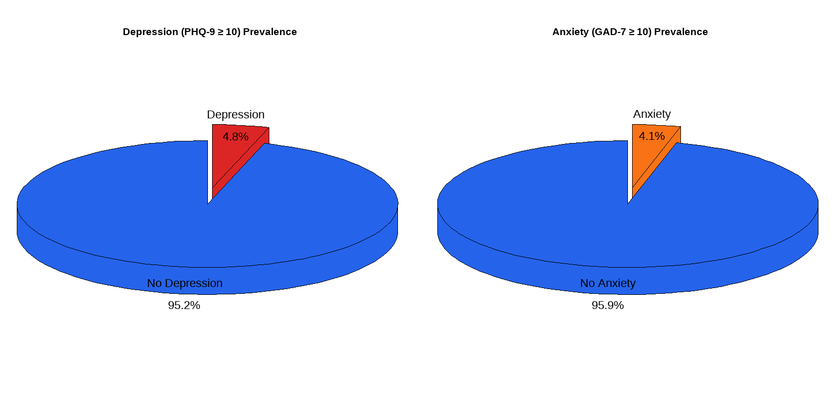
Figure : The Distribution of Mental Health Symptoms

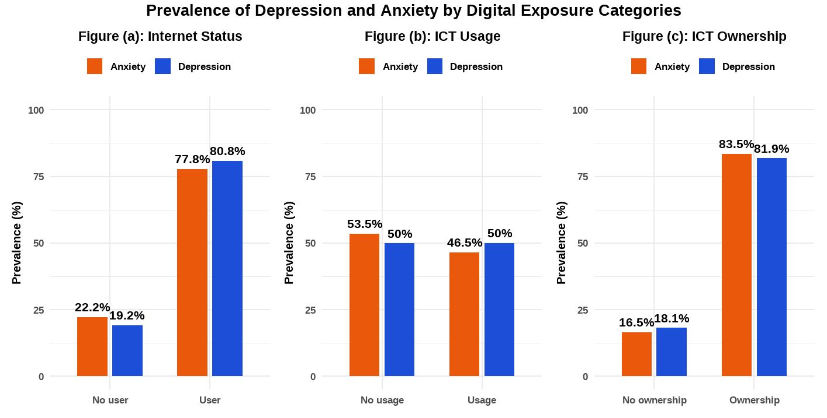
Figure :The Prevalence of Mental Health Symptoms by Exposures Categories

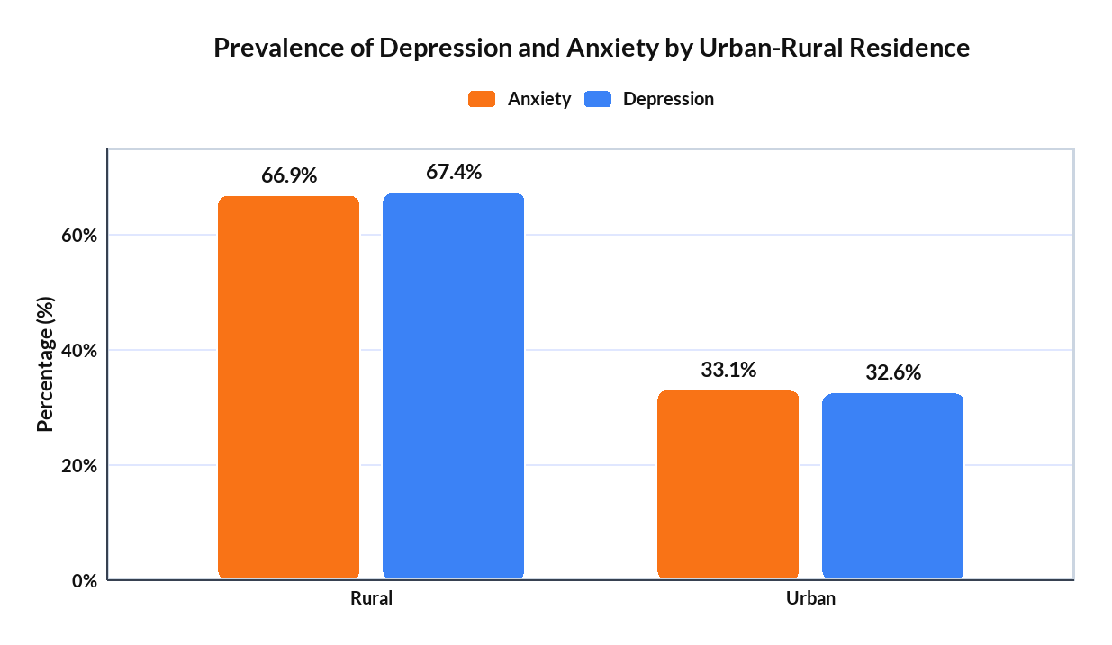
Figure :The Prevalence of Mental Health Symptoms by Residence

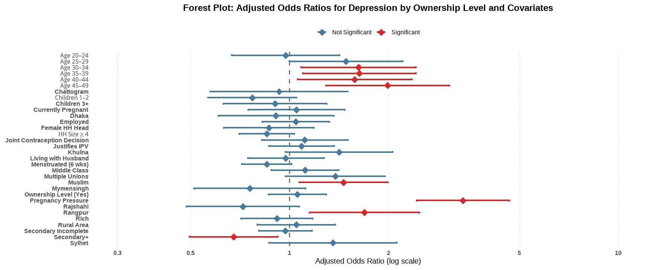
Figure : The Forest Plot of Depression by ICT Ownership

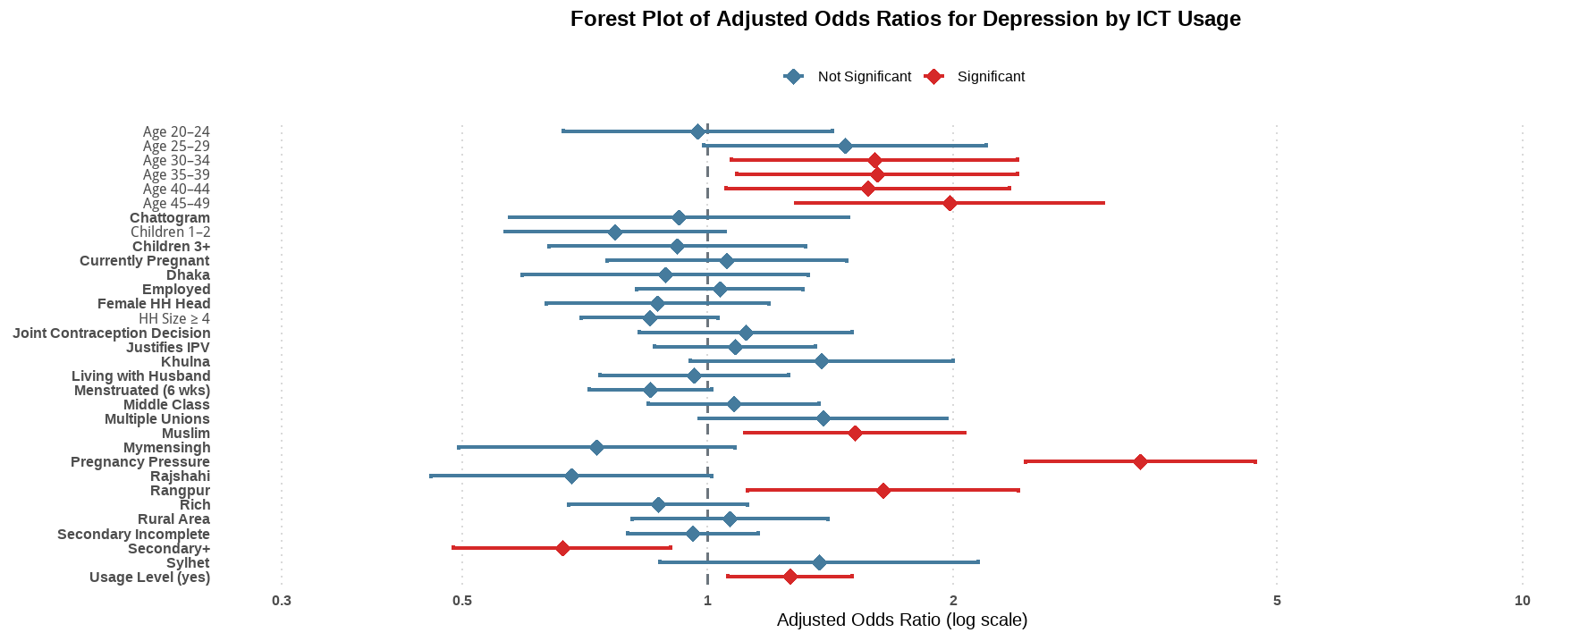
Figure : The Forest Plot of Depression by ICT usage

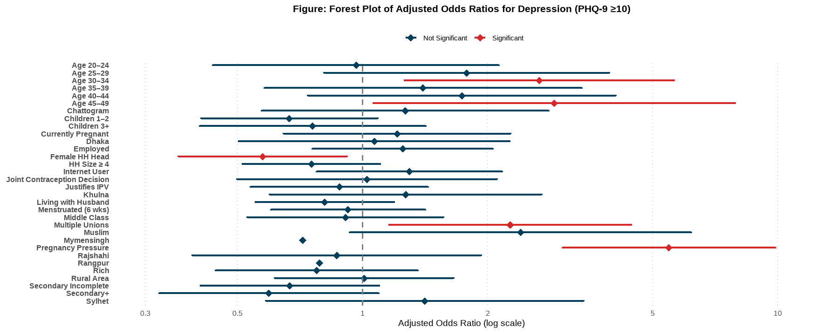
Figure : The Forest Plot of Depression by Internet Use

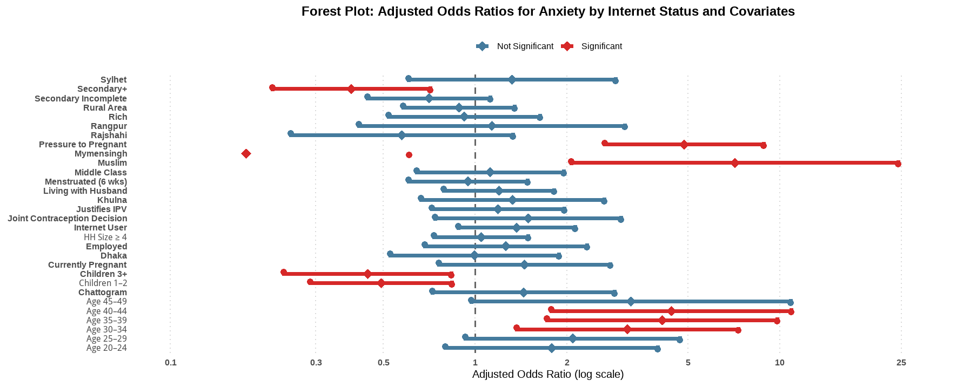
Figure : The Forest Plot of Anxiety by Internet Use

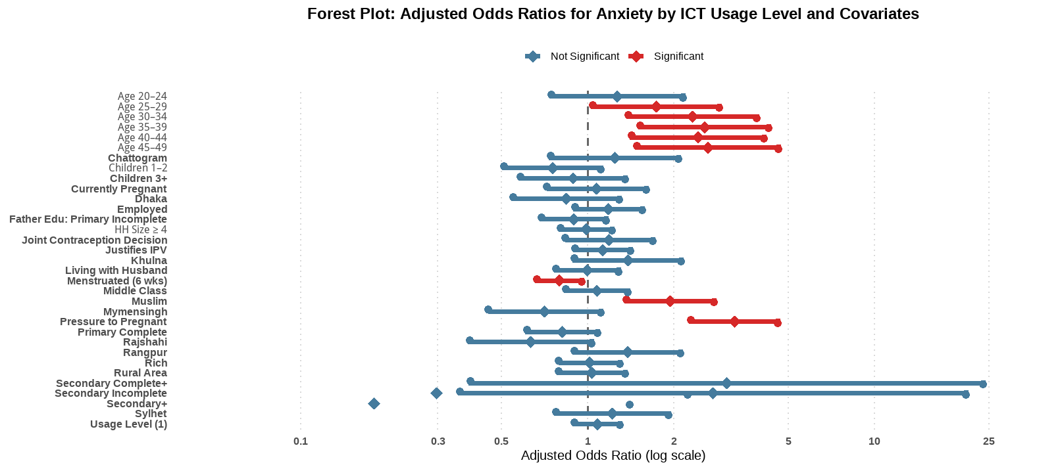
Figure :The Forest Plot of Anxiety by ICT usage

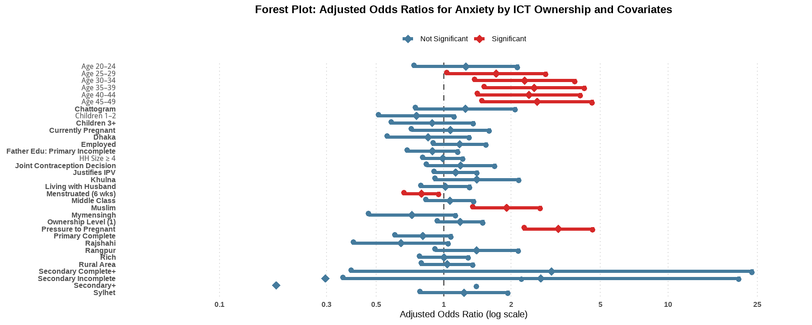
Figure :The Forest Plot of Anxiety by ICT Ownership

Figure : Geo-spatial variation of Anxiety Prevalence and Digital Exposure
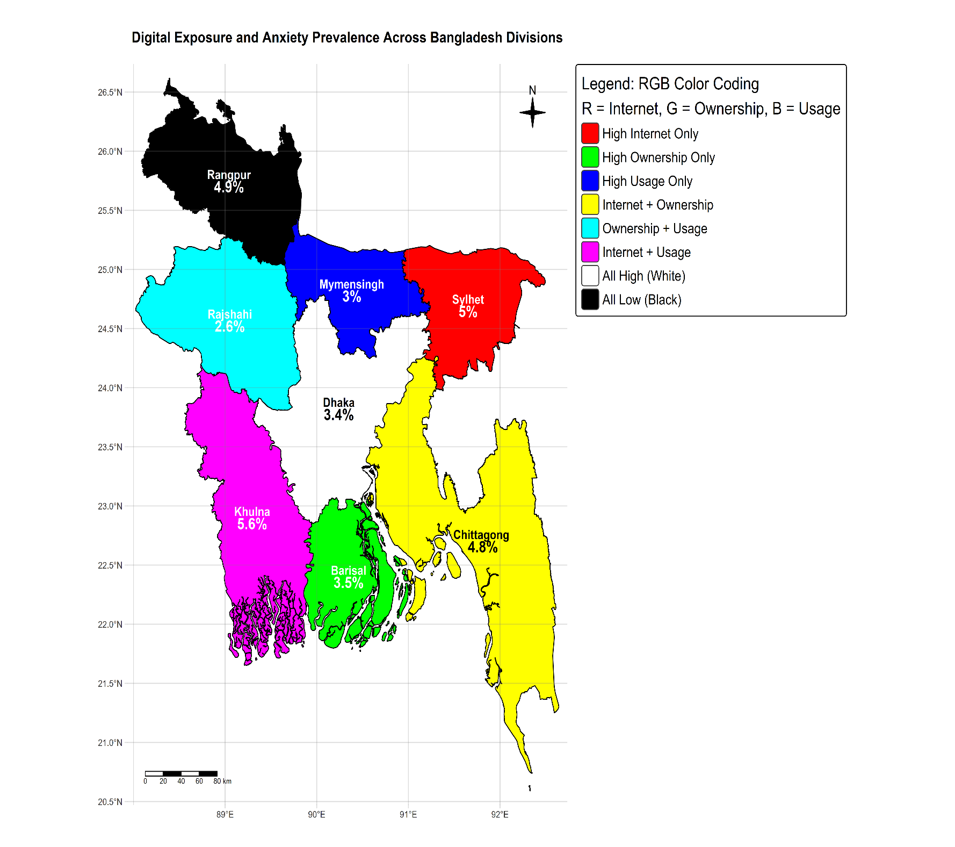

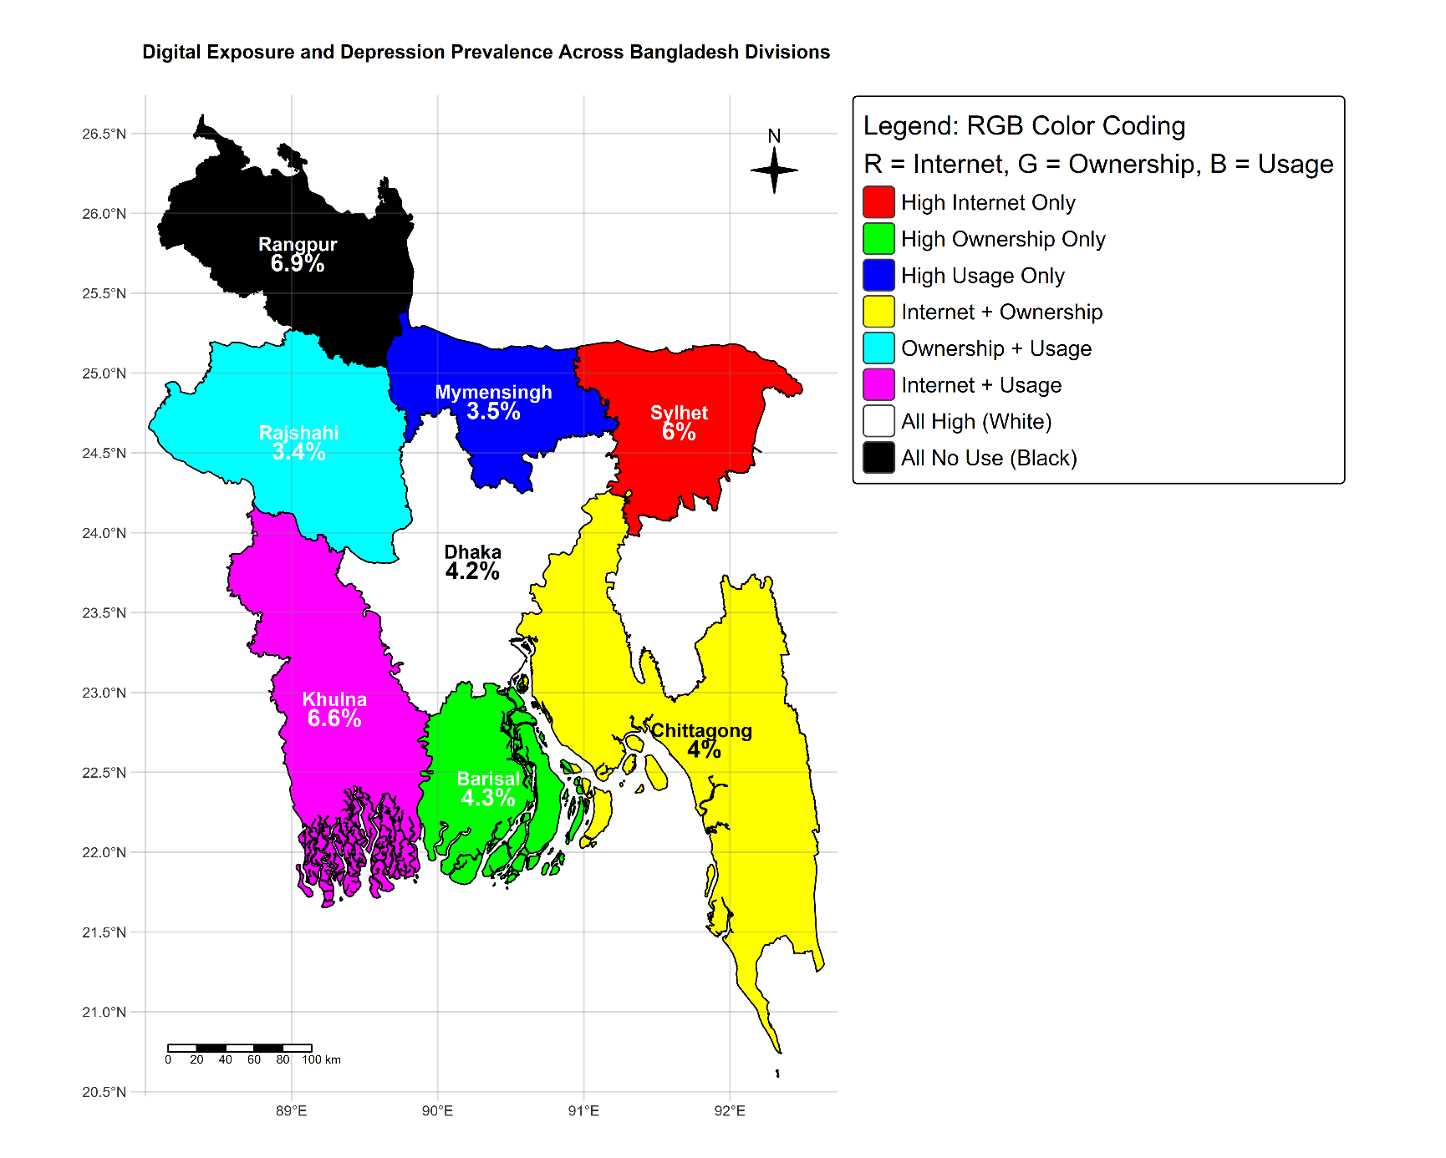
Figure :Geo-spatial variations of Depression Prevalence and Digital Exposure

